**GOKART DESIGN CHALLENGE 2018**

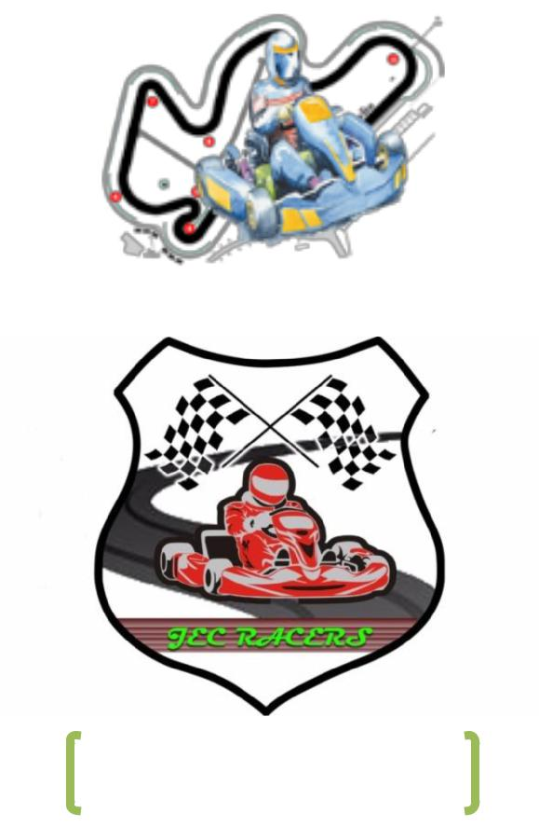

ONWARDS ON WINGS

**DESIGN REPORT**

|  |  |  |
| --- | --- | --- |
| TEAM NAME | : | JEC RACERS |
| TEAM ID | : |  |
| COLLEGE NAME | : | JABALPUR ENGINEERING COLLEGE |
| CITY, STATE | : | JABALPUR, MADHYA PRADESH |

|  |  |
| --- | --- |
| **NAME** | **DESIGNATION** |
| Utsav soni | Team Captain/Steering/Driver/Manufacturing Head |
| Asgar Khan | Market Analysis/Business Plan |
| Deo Raj | Designing/Analysis |
| Ganesh Sing Tomar | Brakes Head |
| Palash Sahu | Innovation |
| Shreya Shrivastava | Team Manager |
| Indu Singh | Brakes/Manufacturing |
| Ghudale Tushar | Electrical |
| Mayank Agrawal | Transmission |
| Suyash Agrawal | Transmission |
| Ashish Gupta | Designing/Analysis |
| Ajeet Gautam | Steering/Manufacturing |
| Sanskar Sethiya | Transmission |
| Sahil Tiwari | Designing |
| Robin Rajak | Team Manager |
| Saket Khare | Brakes |
| Manu Vishwakarma | Designing |
| Pranjal Garg | Manufacturing/Market Analysis |
| Ashish Mahajan | Manufacturing |
| Pradumna Jindal | Manufacturing |
| Himanshu Shukla | Brakes |
| Brijesh Shah | Electrical |
| Harshit Jain | Brakes |
| Abhijeet Singh Tomar | Electrical |

1. **ABSTRACT**:

I

The Go Kart Design Challenge provides a platform for graduate and diploma students to fabricate their own go karts and compete against students from various colleges around the country. Our aim is to design a Go kart in the best possible manner considering the technical guidelines provided in the rulebook. We endeavour to design a Go kart that can successfully take on the challenges yet to come.

1. **INTRODUCTION**:

Team JEC Racers is a team from Jabalpur Engineering College, participating for the first time in Go-Kart Design Challenge 2018. The team consists of 24 members most of whom are from the 3nd year of mechanical engineering.

1. **PROJECT OBJECTIVE**:

The project objective of our team is to design a Go Kart keeping in mind the rules of the rulebook while maintaining proper engineering practices. The main goal of this project is to apply our design and engineering knowledge into practicality and to validate the same designs by manufacturing the Go Kart. By doing so we should be prepared to take on any challenge posed by

|  |  |  |
| --- | --- | --- |
| **S.NO.** | **PARAMETER** | **VALUE** |
| **1.** | Overall Length | 72.6” |
| **2.** | Wheel Base | 42” |
| **3.** | Front Wheel Track | 38” |
| **4.** | Rear Wheel Track | 38” |
| **5.** | Turning Radius | 1.78” |
| **6.** | Steering Ratio | 1:1 |
| **7.** | Steering Mechanism | Four Bar Linkage, Ackerman with Tripod |
| **8.** | Steering Wheel Diameter | 10” |
| **9.** | Braking System | Hydraulic Disc |
| **10.** | Brake Disc Diameter | 6.3” |
| **11.** | Pedal Ratio | 5:1 |
| **12.** | Front Wheel Diameter | 10” |
| **13.** | Rear Wheel Diameter | 11” |
| **14.** | Gear Box | 5-speed constant mesh |
| **15.** | Engine | BAJAJ Discover DTS-i125cc, 4-stroke petrol, air-cooled |
| **16.** | Max. Engine Torque | 10.8Nm@8000rpm |
| **17.** | Acceleration | 5.82 m/s2 |
| **18.** | C.G. Height | 7.8” |
| **19.** | Ground Clearance | 1.5” |
| **20.** | Chassis Material | AISI1018 |
| **21.** | Front wheel  Diameter × thickness | 10”×5” |
| **22.** | Rear wheel  Diameter × thickness | 11”×7” |

**IV. FULLY DEVELOPED CAD MODEL**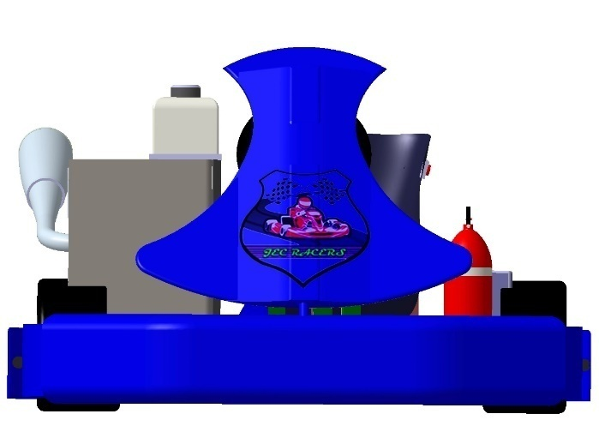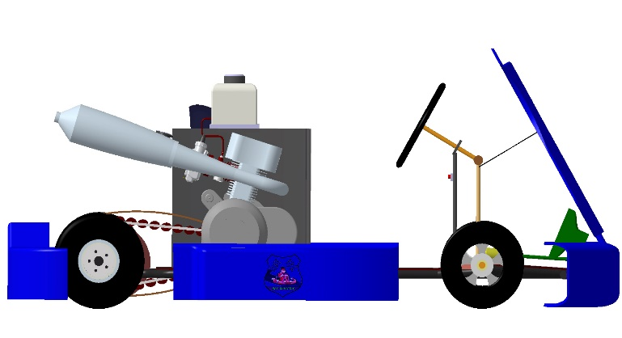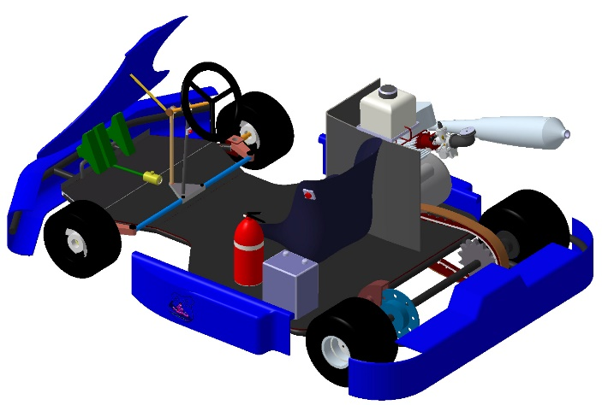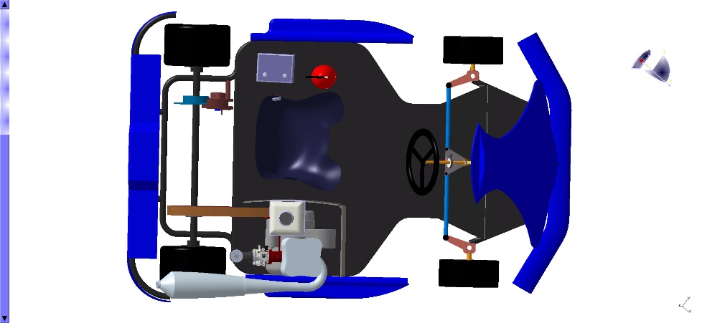

Fig. (a) Front View

Fig. (b) Top View

Fig. (c) Side View

Fig. (d) Isometric View

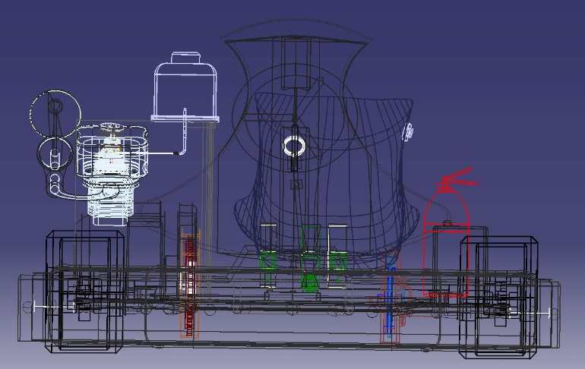

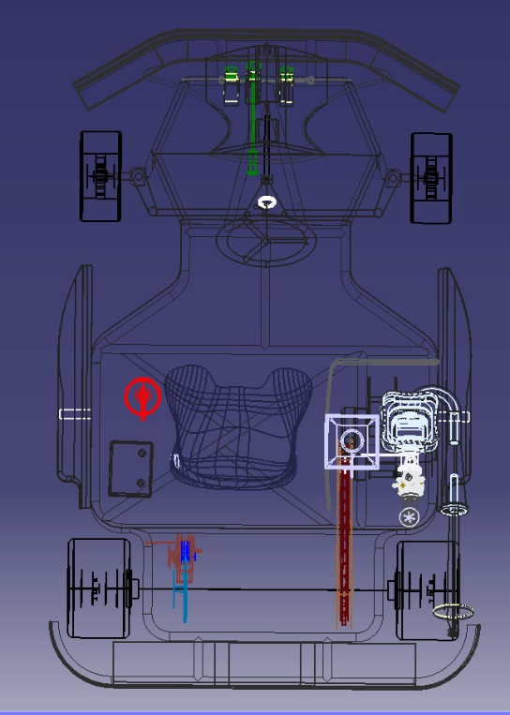**VI. CHASSIS**

Fig. (f) Top View

Fig. (e) Front View

Fig. (g) Side View

MATERIAL SELECTION

By determining the tubing available for space frames and within regulation of the ISNEE chassis specification. We found the following possible tubing materials –

1. AISI 1020 STEEL
2. AISI 4130 STEEL
3. AISI 1018 STEEL

The material used in making up of the go kart is AISI 1018. It has been used in the form of tubes which are seamless. The cross section is is about 1inch, for pipe it will be the outer diameter. Because of its good weld ability, good impact strength, good yield strength as well as good manufacturability and ease of market availability, we have chosen AISI 1018.In fabrication we are using electric arc welding because of following reasons:

* 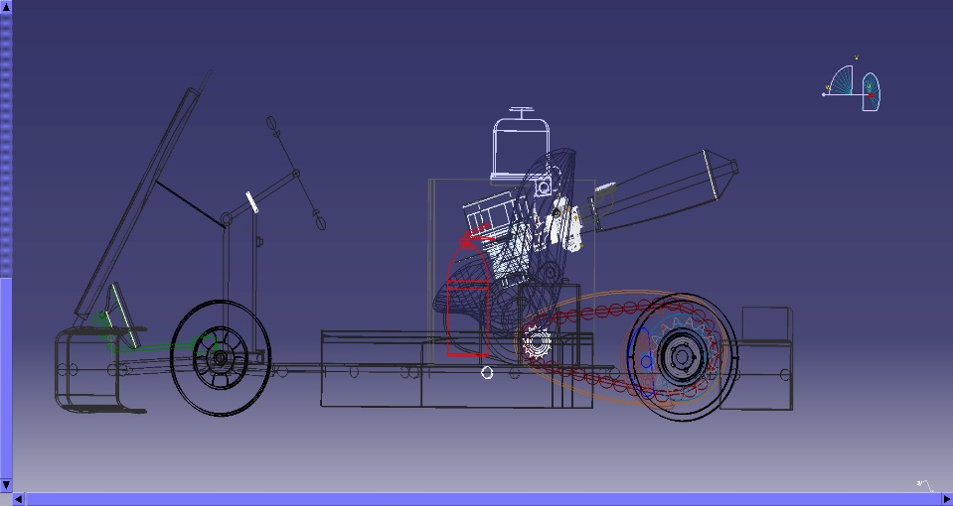it is easily available,
* requires less skilled labour work and
* Uses consumable flux coated welding electrodes.

|  |  |  |
| --- | --- | --- |
| Material Properties | | AISI 1018 |
| Density(gm/cc) | | 7.87 |
| Elastic Modulus(GPa) | | 205 |
| Elongation At Break (%) | | 15 |
| Poisson Ratio | | 0.29 |
| Specific Heat Capacity(J/Kg-K) | | 487 |
| Strength To Weight Ratio  (KN-m/Kg) | | 54-59 |
| Tensile Strength | Ultimate (MPa) | 440 |
| Yield (MPa) | 365 |
| Thermal Expansion(µm/m-K) | | 12 |
| Composition (%) | | Fe: 98.8-99.26  Mn: 0.6-0.9  C: 0.14-0.2  S: 0-0.050  P: 0-0.040 |

**VII. FRAME DESIGNING, SIMULATION AND**

**RESULTS**

INTRODUCTION AND PURPOSE

The chassis is the most important part of the Go-kart as it houses all the other sub-systems and components of the Go-kart. The chassis must be designed to keep the driver safe if any collisions occur and must provide a stiff backbone for all of the components of the car to operate correctly. An optimal chassis must be lightweight and rigid that allows for very little deflection under static and dynamic conditions. If any part of the chassis fails, it would be detrimental to the entire vehicle, so proper consideration must be done in order to not have any failures.

FRAME DESIGN

The frame is designed by keeping in mind all the technical requirements of competition; the objective of the chassis is to encapsulate all components of the kart, including a driver, efficiently and safely. Principal aspects of the chassis focused on during the design and implementation included driver safety, drive train integration, and structural weight, and operator ergonomics. While designing chassis the 1st priority was given to driver safety.

Several factors were considered when deciding on the overall design of the vehicle. . Integration of bent sections was important for two reasons:

1. Limiting the number of tubes intersecting at a welded joint simplifies the welding process.
2. Bent sections reduce the total number of structural members in the chassis

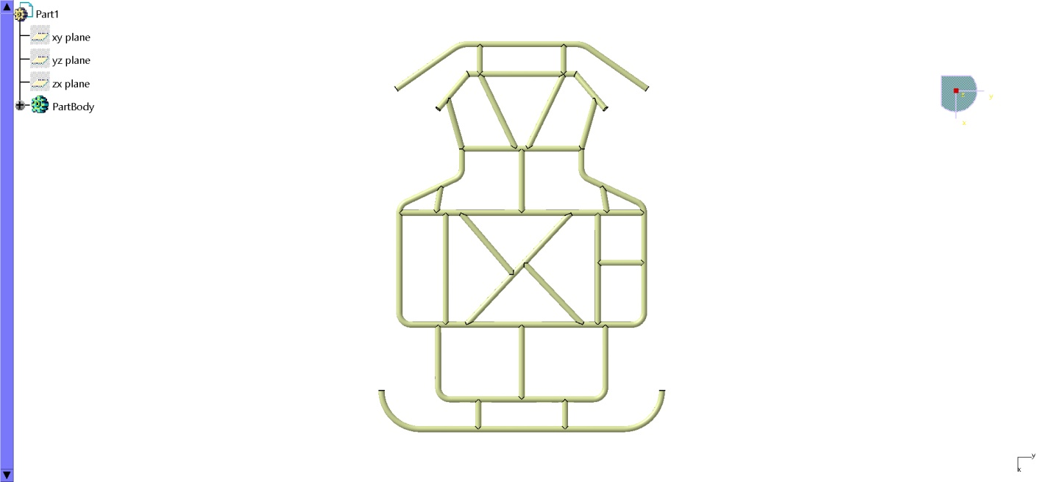

Fig. (h) Top View

**VIII.STRUCTURAL ANALYSIS:**

JUSTIFICATION OF LOADS FOR ANALYSIS OF FRAME:

The next stage in the design process is to analyze the frame & add features accordingly. FEA (Finite element analysis) is then done on the Chassis to make sure that the proposed design is strong enough to withstand the loads of collision. For these reasons it was deemed that there should be an analysis of front impact, rear impact & side impact. However before the analysis are performed, an estimation of the loading forces exerted on the go-kart must be completed.

**Calculation of Impact force:**

It is assumed that after collision with rigid stationary object; the go-kart comes to rest. The estimation of impact force was done by using “Impulse- Change Kinetic Energy theorem”.

Kinetic energy = ½mv2

Work done = F × d = F × V∆t

Where,

∆t is impact time

* ½(mv2) = F × V∆t

F = ½ mv/∆t

1. Front/Rear impact

It has been observed that impact time for front/rear impact is around 0.18sec and for side impact it is around 0.3sec

F = ½ × 160 × 16.66/0.18

F = 7404.4N

1. Side Impact

F = 4426.6N

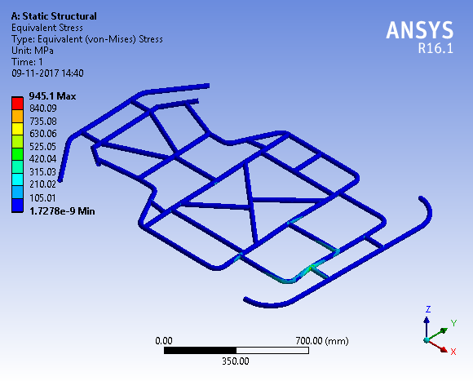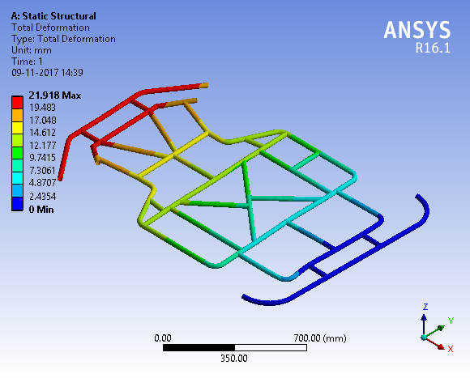

Fig. (i) Front Impact Deformation

Fig. (l) Front Impact Stress

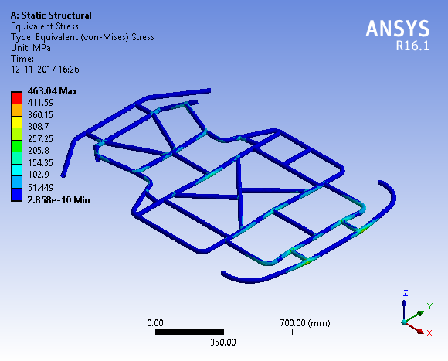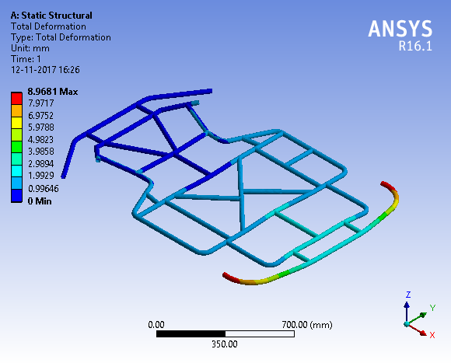

Fig. (j) Rear Impact Deformation

Fig. (m) Rear Impact Stress

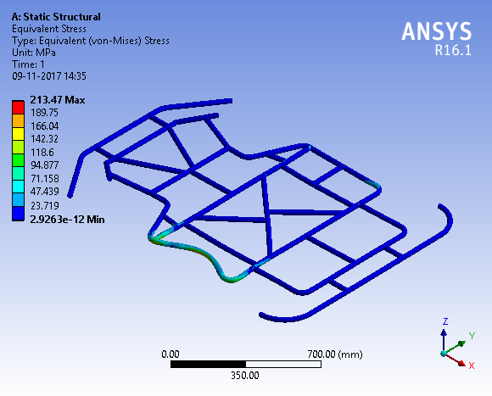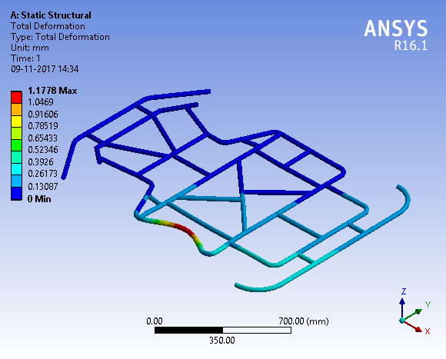

Fig. (k) Side Impact Deformation

Fig. (n) Side Impact Stress

IX. STEERING SYSTEM

DESIGN OBJECTIVES

* A steering system must offer sufficient precision for the driver to actually sense what is happening at the front tyres contact patches as well as enough “feel” to sense the approaching cornering limit of the front tyres..
* It must be structurally stiff to avoid component deflections.
* The steering must be fast enough so that the vehicle’s response to steering wheel inputs and to steering correction happens almost instantaneously and it must also have some self-returning action.
* The feel, feedback and self-returning action are function of the kingpin inclination, scrub radius, castor angle and self-aligning torque characteristics of the front tyre.

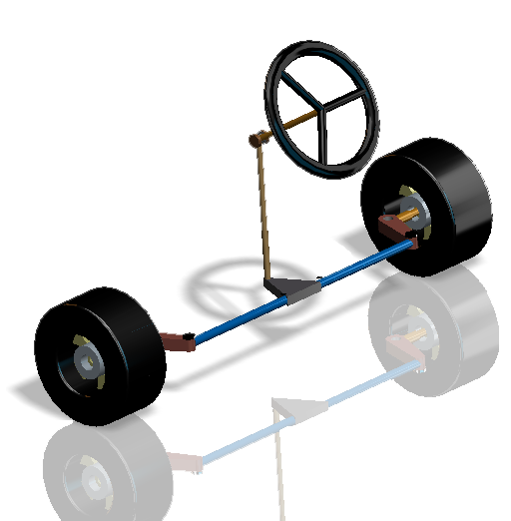

Fig. (o) Steering System

**WHY ACKERMANN?**

* With Ackermann, the inner wheel has less steering angle than the outer wheel but has more grip (unless your tyre would like more slip angle at lower vertical load)

Hence dimensions and angles of the steering column are:

|  |  |
| --- | --- |
| Diameter of steering column | 25 mm |
| Camber angle | 0° |
| Caster angle | 5° positive |
| King Pin Inclination | 5 |
| Turning Velocity | 6 m/s (21.6 kmph) |
| Steering Arm length | 127mm(5”) |
| Tire Width | 127 mm |
| Radius of Wheel | 127 mm |
| Radius of Steering | 130 mm |
| Total Mass | 160 kg |
| Front Axle Load | 68.8 kg |
| Load on each Wheel | 34.4 kg |
| Tripod Radius | 76.2 mm |
| Inner turning angle | 400 |
| Outer turning angle | 25.50 |

**Steering calculations:**

Wheel base (W)= 1066.8 mm (42”)

Track width (B) = 965.2 mm (38”)

Turning angle of inner wheel positively locked at 40° (θi = 40°)

Length of steering arm = 5”

$$\frac{1}{tanθo}-\frac{1}{tanθi}=\frac{B}{W}$$

Θo = 25.5°

**Turning Radius**

R1

R1 = 69.05inches

$$R=\sqrt{{R_{1}}^{2}+b^{2}}$$

(Where R is, min. turning radius)

Since, b= 42 × 0.4 = 16.8”

R = 71.06 inches = 1804.9mm = 1.80m

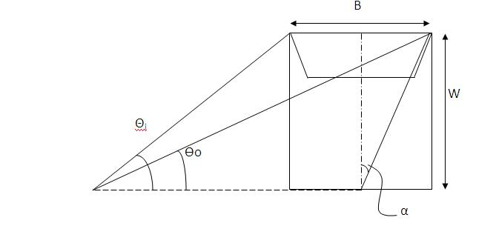

Fig. (p) Steering geometry

**Ackermann angle**

Tanα = (B/2)/W

α =28/ (2×42) = 18.43°

The Ackermann angle is 18.43°

**Length of tie-rod**

Since our steering column is in the centre the tie-rods are of same length.

$$Sinα=\frac{y}{lengthofAckermanarm}$$

Hence y =1.58 inch

⸪ Length of tripod = 3inch

⸫ Length of shorter tie rod = 10.921inch

Length of the longer tie rod = 10.92inch

**DYNAMIC CONDITION:**

Turning Radius Centre of Gravity = 1.8 m

Turning Radius Inner Wheel = 1.6 m

Turning Radius Outer Wheel = 1. M

Height Centre of Gravity (h) = 198.92 mm

1. Weight transfer at cornering

= W(V2/2g) × (h/B)

= 27.19kg

1. Weight on Inner Wheel -

= (Load on Inner Wheel – Weight

Transfer at

Cornering)

= (34.4 – 27.19)

= 6.81 kg

1. Weight on Outer Wheel -

= (Load on Outer Wheel + Weight transfer at cornering)

= (34.4 + 27.19)

= 61.19 kg

1. Lateral Force on Inner Wheel -

= (Weight on Inner Wheel × Turning Velocity2) /Turning Radius Inner Wheel

= (6.81 × 36) / 1.82

= 134.70 N

1. Lateral Force on Outer Wheel -

= (Weight on Outer Wheel × Turning Velocity2) /Turning Radius Outer Wheel

= (61.19 × 36) / 2.63

= 837.58 N

1. Moment due to Lateral Force –
2. Moment Inner Wheel

= (Lateral Force on Inner Wheel × Radius of Wheel × tan (caster angle))

= (134.70 × 127 × tan (5))

= 1496.6 N-mm

1. Moment Outer Wheel

= (Lateral Force on Outer Wheel × Radius of Wheel × tan (caster angle))

= (837.58 × 127 × tan (5))

= 9306.42 N-mm

1. Moment at Kingpin due to Lateral Force

= Moment Inner Wheel + Moment Outer Wheel

= 1496.6 + 9306.42

= 10803.07 N-mm

1. Self-Aligning Torque -

* Moment due to Self-Aligning Torque Inner Wheel

= (Lateral Force on Inner Wheel × (Contact Patch/ King Pin Inclination))

= (134.7 × (90 / 5))

= 2424.6 N-mm

* Moment due to Self-Aligning Torque Outer Wheel

= (Lateral Force on Outer Wheel × (Contact Patch / King Pin Inclination))

= (837.58 × (90 / 5))

= 15076.44 N-mm

* Moment at Kingpin due to Self-Aligning Torque

= Moment Inner Wheel + Moment Outer Wheel

= 2424.6 + 15076.44

= 17501.04 N-mm

1. Net Moment at Kingpin -

= Moment due to Self-Aligning Torque + Moment due to Lateral Force

= 10803.07 + 170501.04

= 28304.11 N-mm

1. Perpendicular force at Steering Arm -

= Net Moment at Kingpin / Steering Arm Length

= 28304.11 / 108

= 262.07 N

1. Force along Tie-rod at arm end -

= Perpendicular force at Steering Arm / [cos (φ1+φ3) × cos (φ2)]

= 274.006 N

1. Force along Tie-rod at rack end -

= Force along Tie-rod at arm end / Tripod efficiency

= 274.006 / 0.9

= 304.45 N

1. Horizontal force at rack end -

= Force along Tie-rod at rack end / [cos (φ1) × cos(φ2)]

= 304.45 N

1. Actual Horizontal force at rack end –

= Horizontal force at rack end / rack efficiency

= 304.45 / 0.9

= 338.27 N

1. Moment at Steering Column -

= Actual Horizontal force at rack end × Tripod Radius

= 338.27 × 42

= 14207.34 N-mm

1. Steering Effort -

= Moment at Steering Column / Radius of Steering

= 14207.34 / 130

= 109.28 N

**X. BRAKE SYSTEM**

The purpose of the brakes is to stop the kar safely and effectively i.e. with shorter stopping distance

In Braking System, Our basic aim was to calculate the dimension of brake disc by considering the torque developed by the system that would be greater than that required by our kart.

For this we had done iterations on master cylinder’s bore diameter to obtain appropriate value of disc size.

|  |  |  |
| --- | --- | --- |
| **Master Cylinder Bore Size (inches)** | **Brake Pad Area**  **(m2)** | **Disc Mean Diameter**  **(mm)** |
| 7/8 | 8.0424 × 10-4 | 200 |
| 3/4 | 8.04242 × 10-4 | 130 |

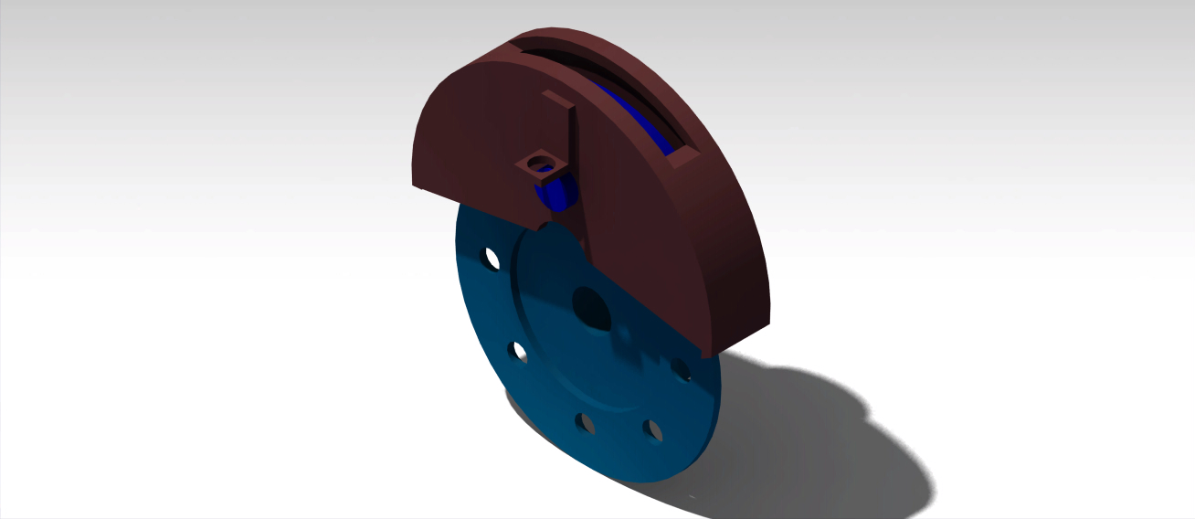

**Specifications**

Fig. (q) Disc with Calliper

|  |  |
| --- | --- |
| Paddle Ration | 5:1 |
| Master cylinder Piston Diameter | 3/4“ |
| Calliper Piston Diameter | 32mm |
| Coefficient of friction (Tyres) | 0.7 |
| Coefficient of friction (Brake-Pads) | 0.4 |
| Wheel radius | 11 “ |
| Weight of Kart  (with Driver) | 160kg |

**Brake Calculation**

* Area of Master Cylinder Piston

A1 = πD2/4 = 3.141 × (0.01905)2/4

= 2.8 × 10-4 m2

* Area of calliper Piston

A2= πD2/4 = 3.141 × (0.032)2/4

= 8.04 × 10-4m2

* Brake Disc Diameter

Force acting on kart = m. a1 = 160 × a1

Frictional Force = 0.7 × 160 ×9.81

m.a1 = µ1mg

a1 = 6.867 m/s2

Force on Kart = 160 × 6.867 =1098.72N

Driving torque acting T = Force on kart ×wheel radius

= 1098.2 × .1397

=153.41 Nm

Force applied by driver on pedal = 200N

Pedal ratio = 5:1

Therefore, force on MC piston = 1000N

Pressure on MC piston =

1000/A1 = 3571428.57 Pa

This pressure is applied to at calliper piston

Therefore, Clamping Force F1

= 2 × MC pressure × A2

= 2 × 35671428.57 × 8.0424 × 10-4

= 5744.57 N

Clamping friction force F2 = F1 ×µ2

= 5744.57 × 0.4

= 2297.82 N

Now,

Braking torque developed by system must be equal to the torque required by kart

2297.82 × mean radius of disc = 153.41

Mean disc radius = .060m

Mean disc diameter = .130m = 130 mm

Internal diameter = 80 mm

Outer diameter = 180 mm

* Deceleration

a2 = F2/m

= 2297.82/160

=14.1 m/s2

* Stopping distance

Velocity of vehicle = 60 km/hr

S = v2/2a2 = 9.85 m

* Stopping time

T = v/a2 = 1.2 s

**Considering Drivers Reaction Time**

TIme

tr ts

Velocity

Fig. (r) Velocity-Time Graph

Taking reaction time as 1 seconds

Stotal = V.tr + V. ts/2

= 16.6 × 1 + 16.6 × 1.2/2

= 26.6 m

Stopping time = driver’s reaction time + brake system execution time

T = TD + TS

= 1 + 1.2

= 2.2 s

**Volumetric Losses to be considered In Braking System**

* The clearance between rotor and braking should be kept optimum.
* Due to the expansion of brake line the efficiency of system decreases.
* Volume of master cylinder should be greater than volume required by calliper piston. This will justify the selection of master cylinder.

**Brake Fluid**

DOT 3 is one of the several designations of automotive brake fluid, denoting a particular mixture of chemicals imparting specified range of boiling points.

It is a polyethylene glycol-based fluid. This fluid is hygroscopic. And will absorb water from the atmosphere. Its Boiling Point is-

• DRY BOILING POINT: 205°C (401°F)

• WET BOILING POINT: 140°C (284°F)

Force required to cause rear tires to skid = Ft=µ (NR + NL) µ= coefficient of friction between car and road

NL is normal force on rear left tire.

NR is normal force on rear right tire

**Wheels**

Slick tyres generally have low rolling resistance coefficient ranging from 0.025 – 0.04 on asphalt. Slick tyres maintain traction even in damp conditions. They do not get deformed under high load. We have used standard Go-Kart tyres.

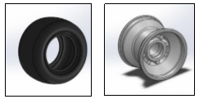

Fig. (s) Wheel & Tyre

**XI. Transmission And Power**

The specifications of engine are as follows:

|  |  |
| --- | --- |
| Cylinder Arrangement | Single cylinder inclined  15° from vertical |
| Bore & Stroke | 58 x 57.9 mm |
| Acceleration | 5.82 m/sec2 |
| Displacement | 124.9cc |
| Compression ratio | 9.5:1 |
| Transmission | 5-Speed/Constant Mesh |
| Cooling system | Natural Air Cooled |
| Engine dry weight | 24.9 kg |
| Ignition System | DTS-i |
| Clutch | Wet Multi-plate type |

**Assumptions: -**Some important assumptions are as follows**:-**

* μs:- 1.25
* μr:- 0.03
* Mass of the vehicle: -160 Kg (with driver) Now,

Max. rpm = 8000 rpm

Max. Torque = 10.8 Nm @5500 Max. Power = 10.9 bhp@8000

Gear Ratio:

1. 2.714
2. 1.789
3. 1.318
4. 1.045
5. 0.915

Primary Reduction: 3.409

Final Reduction: 2.80

**ITERATIONS:**

|  |  |  |  |  |
| --- | --- | --- | --- | --- |
|  | Rear Wheel | Acceleration | Max. |  |
| S. No. | Diameter | Speed |  |
| (m/s2) |  |
|  | (in) |  | (kmph) |  |
|  |  |  |  |  |
| 1. | 11 | 5.34 | 78.6 |  |
|  |  |  |  |  |
| 2. | 12 | 4.79 | 85 |  |
|  |  |  |  |  |
| 3. | 13 | 4.33 | 92.7 |  |
|  |  |  |  |  |
| 4. | 14 | 3.94 | 99.8 |  |
|  |  |  |  |  |

**Angular Velocity (ω at driven Sprocket)**

(ω = 2πN/60) N is Rev./minute

At 3000rpm = 314.15rpm

At 3500rpm = 366.51rpm

At 4000rpm = 418.87rpm

**WorkDone**

(Work done = Torque ×ω)

At 3000rpm = 10.8 × 314.15

= 3392.82 Nm-rpm

At 3500rpm = 10.8 × 366.51

= 3958.30 Nm-rpm

At 4000rpm = 10.8 × 418.87

= 4523.79 Nm-rpm

**Rolling Resistance**

Rolling Force F = μ × W

Where,

μ = Coff. Of Friction = 0.03 (Assume)

W = 160kg

F = 160 × 0.03 = 48N

Rolling Torque

Tr = F × R [(r1 + r2)/2 ]

= 320 × 0.133

Tr = 42.67 Nm

**Drag Force**

FD= ( ρ.u2.Co.A)/2

Where,

ρ (Air Density) = 1.1 kg/ m2

u (Velocity) = 60 km/hr (16.68 m/s)

Co (Drag Co-efficient) = 0.3 (Assume)

A (Projected Area) = 0.7 m2

⸫ FD= 32.14 N (Appro×. 40 N Considering Drag due to other)

**Force Required to start the Kart from Rest**

F = m × a

= 160 × 5.82

= 932 N

Now calculated torque (at 8000 rpm)

$10.9 ×746= \frac{T×8000×2π}{60}$

T = 9.706 Nm

Now torque on the wheel (Tw) (Assuming 90% transmission efficiency) Pw = 0.9× PE

= 9.81 HP

$9.81×746=\frac{T_{W}×8000×2π}{G_{R}×60}$

On first Gear ratio, Tw = 8.73 Nm× GR

= 8.735 × 3.409 × 2.714 × 2.8

= 226.2 Nm

Now, Resisting Force,

Suppose Net resisting force = FR

FR = F1 + F2 + F3 + F4

F1 = Rolling Resistance

µmg

0.03×160×9.8

47.04 N

F2 = Air Drag

Cdρu2A

40N (assume)

F3 = Grade ability (10º inclination if available)

mgsin 10º

272.2 N

F4 = Inertial Resistance (Due to rotating part)

= 100N (assume)

Now, FR = F1 + F2 + F4

= 187.04N (without grade ablility)

FR = 459.24 N (When vehicle is moving 10® uphill)

Tractive force applied on first gear,

$$\frac{T_{F}}{RollingRadius}=226.3$$

Where rolling radius RR = R×0.96 = 0.1341

Hence tractive force,

$$T_{F}=\frac{226.3}{0.1341}=1687.44N$$

Now, acceleration on first gear

$$\frac{1687.44 – 187.04}{160}=a$$

a = 9.377 m/s2 (without gradeability)

a = 7.67 m/s2 (with gradeability) Top speed on first gear (8000 rpm) = 28.9 km/h

Now, acceleration on second gear

Hence tractive force,

$$T_{F}=\frac{149.16}{0.1341}=1112.30N$$

Now, acceleration on first gear

$$\frac{1112.30 – 187.04}{160}=a$$

a = 5.782 m/s2 (without grade ability)

a = 4.08 m/s2 (with grade ability)

Top speed on second gear (8000 rpm) = 46.87km/h

Now, acceleration on third gear

Hence tractive force,

$$T_{F}=\frac{1099.87}{0.1341}=819.46$$

Now, acceleration on first gear

$$\frac{819.46 – 187.04}{160}=a$$

a = 3.952 m/s2 (without grade ability)

a = 2.25 m/s2 (with grade ability)

Top speed on third gear (8000 rpm) = 68.5kmph

Now, acceleration on fourth gear

Hence tractive force,

$$T_{F}=\frac{87.12}{0.1341}=649.6N$$

a = 2.89 m/s2(without grade ability)

a = 1.191 m/s2 (with grade ability)

Now, acceleration on fifth gear

Hence tractive force,

$$T_{F}=\frac{76.29}{0.1341}=568.9N$$

a = 2.35 m/s2 (without grade ability)

a = 0.68 m/s2 (with grade ability)

As we see, acceleration on 5thgear with grade ability is very low such that it takes too much time to reach maximum speed. Hence, our vehicle will drive in 1st and 2nd gear comfortably when it is going 10º uphill.

Top speed on second gear (8000) = 46.87km/h

Top speed on third gear (8000) = 68.5km/h

Top speed on fourth gear (8000) = 93.78km/h

Top speed on fifth gear (8000) = 119km/h

**Conclusion:**

The time taken by the go-kart to reach 60km/h is less than 5 sec.

**SPROCKET RATIO**

Primary Reduction = 3.409

Gear Ratio for Top Gear = 0.91

Max. Engine RPS = 150rps

Max. wheel RPS = 24.1 (at 75 km/h)

Teeth on driver gear = 14

Sprocket Reduction = 150/(3.409 × 0.91 × 24.1)

= 2.00

Teeth on driven sprocket = 14 × 2

= 28

Z1 = No. of teeth on driver sprocket = 14

Z2 = No. of teeth on driven sprocket = 28

**Sprocket Ratio = 28/14 = 2**

**Exhaust Calculation**

An exhaust system is usually piping used to guide reaction exhaust gases away from a controlled combustion inside an engine or stove. The entire system conveys burnt gases from the engine and includes one or more exhaust pipes.

For maximum transmission loss, up to 80-40 dB targeted frequencies should be calculated from maximum rpm.

Cylinder Firing Rate (CFR)

CFR = (Engine speed rpm) / 120 [4 stroke]

= 8000 / 120

=66.67 Hz

Engine Firing Rate (EFR)

n=Number of cylinder

EFR = n $×$ CFR

= 1 $×$ 66.67

= 66.67 Hz

Hole perforators choose to match frequency that needs to be killed based on EFR & CFR

Bore (D)= 58 mm Length (L) = 57.9 mm No of cylinder = 1 Engine power = 10.9 bhp Maximum rpm = 8000 rpm

Allowable back pressure = 10 in H2O Transmission loss noise target (muffler) = 30 dB

Diameters of holes drilled should suppress these frequencies

**Muffler volume calculation:-**

Swept Volume (Vs) = π $D^{2}×$ L / 4

Vs = π $×{58}^{2}×$ 57.9 / 4

Vs = 152976.39

Total volume in litres = 152976.39 10-6 dilution

Factor (3.016)

= 0.46137681 litres

Volume should be considered for calculation

Volume = n $×$ (Vs/2)

= 0.2306884 litres

Actual muffler Volume (Vm) = Factor (for gauge

steel) $×$ Considered

Volume

= 16 $×0.2306884$

Vm = 3.6910144 litres

Diameter of muffler

Vm = L

Length = 20cm (assume)

3.6910144 $×{10}^{3}$ = $\frac{π}{4}×d^{2}×$ 20

d $≈$ 15.3289 cm

Inlet pipe up to 12 cm & outlet pipe up to 14 to 15 cm

$∴$ Diameters of inlet pipe same as diameter of outlet pipe

$∴$ Diameters of inlet pipe = Diameter of outlet of engine

**XII.INNOVATION**

**Vibration Sensing Module :**

**Working :** This entire unit will monitor the vibrations on the parts and components which are vulnerable to excessive vibration which further could lead to material failure or components fatigue or structural failure if the vibrations during the operation of vehicle where sensors are installed reaches above the specified limit then the module will notify the driver and the crew about those vulnerabilities.

1. **Vibration Sensors**

Critical to vibration monitoring and analysis are machine-mounted sensors. Three parameters representing motion detected by vibration monitors are displacement, velocity and acceleration. Mathematically related, the parameters can be taken from a variety of motion sensors. Selection of a sensor proportional to displacement, velocity, or acceleration depends on the frequencies of interest and signal levels that are involved.

Displacement sensors are used to measure shaft motion and internal clearances. Non-contact proximity sensors sense shaft vibration relative to bearings or other support structure. The sensors are used in low-frequency (1 to 100 Hz) measurement and measure low-amplitude displacement typically found in sleeve-bearing machine designs. Piezoelectric displacement transducers solve issues associated with mounting non-contact probes and are more suitable for rolling element-bearing machine designs. Piezoelectric sensors yield an output proportional to the absolute motion of a structure.

Velocity sensors are used for low to medium frequency measurements (1 to 1000 Hz) and are useful for vibration monitoring and balancing operations on rotating machinery. They have lower sensitivity to high frequency vibrations than accelerometers and are therefore less susceptible to amplifier overloads. Overloads compromise low amplitude, low frequency signals. Traditional velocity sensors use an electromagnetic coil and magnet system to generate the velocity signal. Today, piezoelectric velocity sensors are becoming popular due to improved capabilities and their rugged nature.

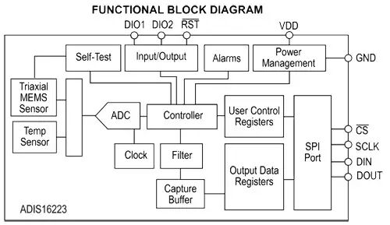

Fig. (t) Block Diagram

1. **Vibration Switch SW420**

**PCB(Printed Circuit Board)**

Arduino Uno is a microcontroller board based

On the ATmega328P. It has 14 digital input/output pins (of which 6 can be used as PWM outputs), 6 analog inputs, a 16 MHz quartz crystal, a USB connection, a power jack, an ICSP header and a reset button. It contains everything needed to support the microcontroller; simply connect it to a computer with a USB cable or power it with a AC-to-DC adapter or battery to get started.

**XIII. REFERENCES:**

1. Bharat K.S. , Prashi Upreti and Anirudh Tripathi ‘STATIC AND DYNAMIC ANALYSIS OF ROLL CAGE’. Imperial Journal of interdisciplinary Research [IJIR], Vol-2, issue-6, 2016.
2. Design of Machine Element by V.B. Bhandari, ISBN : D070681791
3. <http://www.kartbuliding.net>
4. Thomas D. Gillapsie, ‘FUNDAMENTAL OF VEHICLE DYNAMICS’, SAE [PA15096-000]
5. William F. & Douglas L. Milliken,’RACE CAR VEHICLE DYNAMICS’ SAE ,1954
6. I.Y. Wong, Carleton University Canada. ‘THEORY OF GROUND VEHICLES’,3rd Edition, ISBN : 0-471-35461-9

**RESOURCES USED DURING THE PROJECT**

1. **College Resources**

* Workshop
* Machines like Welding, Drilling, Lathe Machine, Cutting, Surface Grinder
* Electricity

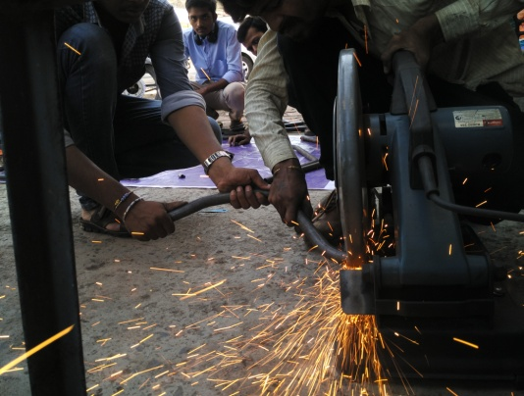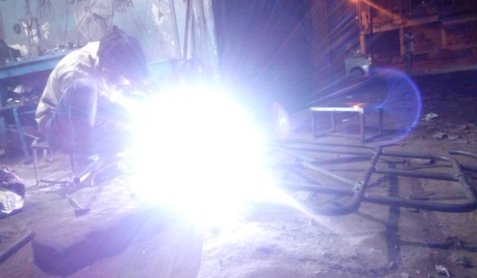

Fig. (u) Pipe Cutting

Fig. (v) Electric Arc Welding

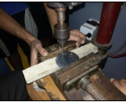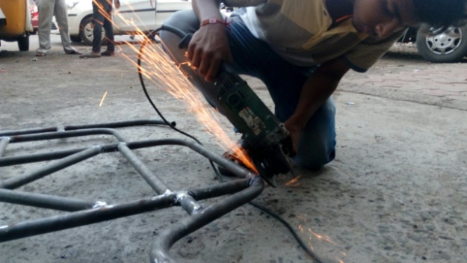

Fig. (w) Drilling

Fig. (x) Surface Grinding

1. **Outsourcing Used**

* Bending Machine
* Grinding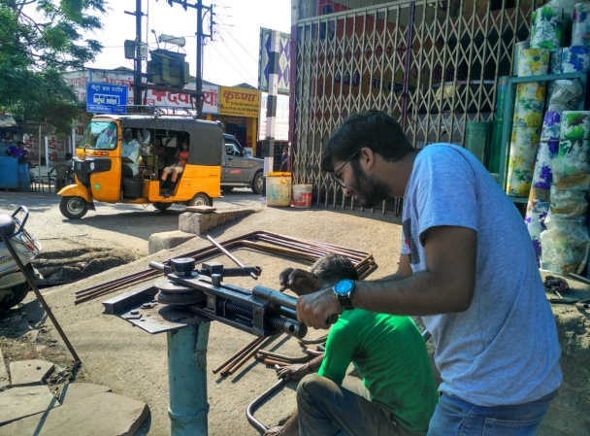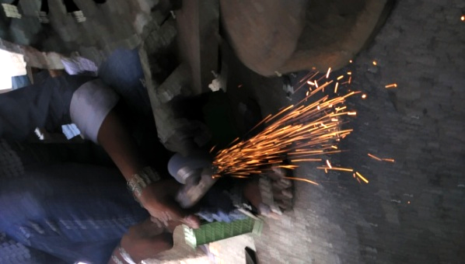

Fig. (z) Grinding

Fig. (y) Bending